Question – 1 [CLO3]
A sender wants to transmit the following data using 16-bit words and the 1’s complement checksum method:
7A2C 91F5 3E10 8B77 6D3A

- Compute the checksum to be transmitted. [4]
- Show the final transmitted message. [2]
At the receiver end, suppose the received data is:
7A2C 91F5 3E10 8D77 6D3A along with correct checksum
- Verify whether an error is detected or not. [5]
- Identify and briefly explain why this error is or is not detected. [4]
SOLUTION
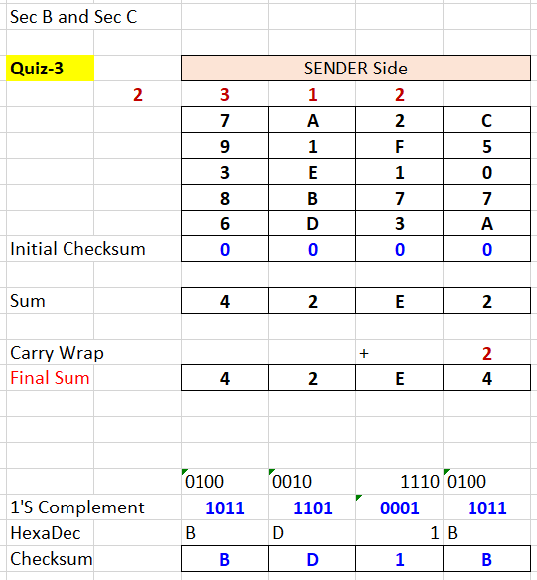 | 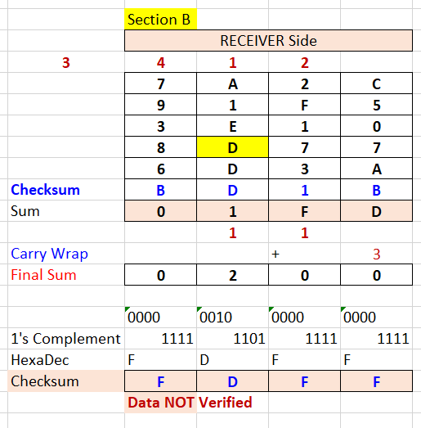
Final transmitted data: 7A2C 91F5 3E10 8B77 6D3A BD1B

Yes. the error has been detected. At the receiver end, one word was changed during transmission 8D777 instead of the word (8B77) sent by the sender. 1-bit change altered the sum

Error has been detected even though a subtle 1-bit error was induced during transmission. So checksum works here and the receiver will know that the data has an error before it is used

